BRING A POWERFUL FAITH EXPERIENCE TO YOUR CHURCH WITH A SPECIAL SCREENING OF BREAKTHROUGH

Host a Meaningful Night of Film, Faith, and Real-Life Testimonies

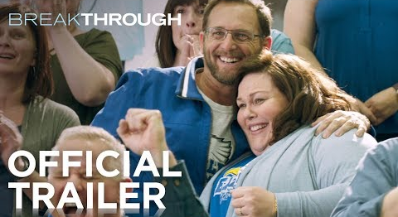
Click on the banner to view film trailer

How would your church like to host a special screening of Breakthrough, followed by a live Q&A with real-life individuals whose story inspired the film?

Churches across the country are being invited to take part in this unique and impactful event that brings together film, testimony, and community. This one-night experience allows congregations to not only watch a powerful true story unfold on screen but also hear firsthand from those who lived it.

About the Event
This special church-hosted event includes:
- A screening of Breakthrough, the inspiring true story of faith and perseverance
- A live Q&A session featuring:
  - Pastor Jason Noble, who was present during critical moments of the story
  - John Smith, whose miraculous survival is at the heart of the film
Following the film, attendees will have the opportunity to hear personal reflections, deeper insights, and messages of hope directly from Pastor Noble and John Smith.
Why Host This Event?
Hosting this event offers churches a chance to:
- Inspire and uplift their congregation through a powerful real-life story
- Create a meaningful community gathering centered on faith and hope
- Provide a rare opportunity to engage directly with individuals behind a widely known miracle story
About the Film
Breakthrough is based on the 2017 book The Impossible: The Miraculous Story of a Mother’s Faith and Her Child’s Resurrection by Joyce Smith with Ginger Kolbaba. The book recounts the real-life story of John Smith, a 14-year-old boy who fell through an icy lake in Missouri and was submerged for over 15 minutes. Declared clinically dead, he survived after his mother’s unwavering prayers, a recovery many regard as miraculous.

ABOUT CHRISTIAN MUSIC TOURS: Christian Music Tours is a division of www.cast.tours a leading Sports and Entertainment tour company with Exclusive Partnerships with The NFL, NBA, NHL< Major League Baseball along with Top U.S. College Football Teams to offer Once in A lifetime Sports Travel Experiences with your favorite players and teams. Christian Music Tours is a world leader in all-inclusive faith-concerts featuring award-winning Christian artists, symphony orchestras, and inspiring choirs. Christian Music Tours brings Scripture to life through unforgettable travel experiences designed to inspire and deepen faith.

Booking Information
To book your church for this special event, please contact: marlan@christianmusictours.com

