THE LARGEST BROADWAY-STYLE PRODUCTION COMING TO CHURCHES IN NORTH AMERICA

Bringing “The Pilgrim’s Progress” artistry directly to you

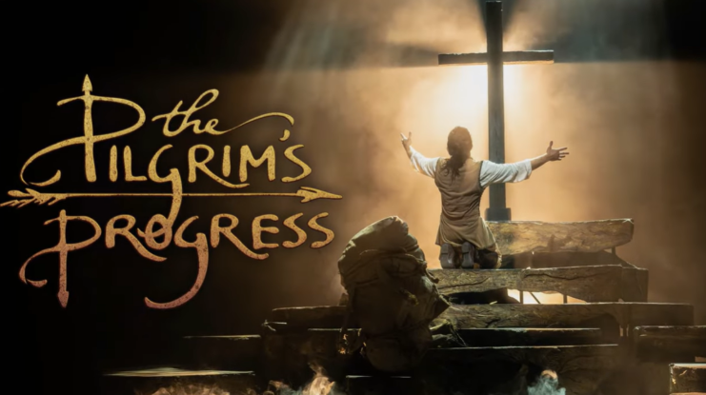
Please Click the Banner to Access a Trailer to the Show

For the first time, the scale and power of a Broadway production is being brought directly to churches across North America. The 2026 North American Church Tour will introduce the largest production of its kind adapted for church venues, offering an opportunity to host a professional theatrical performance within their own space. Featuring a cast and crew of over 40 professionals, this production will deliver energy, storytelling, and visual impact typically reserved for major theatre stages now reimagined for churches.

About The Pilgrim’s Progress
At the heart of the production is the timeless story of The Pilgrim’s Progress, following Christian’s journey from the City of Destruction to the Celestial City. Along the way, he faces danger, temptation, and worldly distractions, encountering characters and challenges that reflect the spiritual struggles of faith, perseverance, and redemption.

Previous Presentation
The production was staged during a residency at the Museum of the Bible in a space not originally designed for large-scale theater. The experience helped refine the production’s technical approach and spatial adaptability for alternative venues. This serves as the foundation for its transition into church environments for the 2026 tour.

Tour Details
The 2026 tour will include a limited number of church locations across North America. Each prospective venue will be assessed to determine whether it can accommodate the technical and spatial needs of the production. Churches interested in participating can begin the process by contacting the production team for further information.

ABOUT CHRISTIAN MUSIC TOURS: Christian Music Tours is a division of www.cast.tours a leading Sports and Entertainment tour company with Exclusive Partnerships with The NFL, NBA, NHL< Major League Baseball along with Top U.S. College Football Teams to offer Once in A lifetime Sports Travel Experiences with your favorite players and teams. Christian Music Tours is a world leader in all-inclusive faith-concerts featuring award-winning Christian artists, symphony orchestras, and inspiring choirs. Christian Music Tours brings Scripture to life through unforgettable travel experiences designed to inspire and deepen faith.

ABOUT LOGOS THEATRE: Since 1971, the Academy of Arts has dedicated itself to bringing the Bible to life through stage and film. Through creative and purposeful storytelling, the organization shares the message of God’s Word while involving young people in the artistic process, equipping them to communicate stories rooted in truth.

###

For more information about “The Pilgrims Progress”, contact Marlan at (626) 824-1769 or marlan@christianmusictours.com

